In the context, we came up with three different data-collection-methods: open-source (social media APIs), traffic data (Google API to monitor cell phone location and velocity) and user-based intel. For the first way – open-source, you said, we can use MongoDB to facilitate NLP and recommendation engines derived from the open-source data. Therefore, in this passage, I will talk about the method to apply traffic data (including the data of seizures) and user-based intel.

In the step of getting traffic data, we can use the software of GAIA, a kind of geography software, to get the basic information of sea routes and land route. For the information of land route, we can get the arrangement of the cities, as figure-7 shows. For the information of sea route, we can write the API-code (figure-8) directly in this software to get the real-time location of coast guard (figure-9). In this case, we can easily and safely ship the drug from Mexico to America on marine routes.

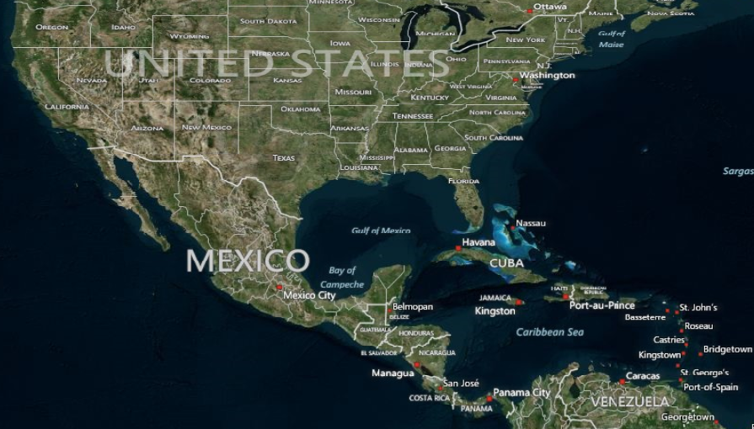
Figure-7- micromap visual earth from GAIA

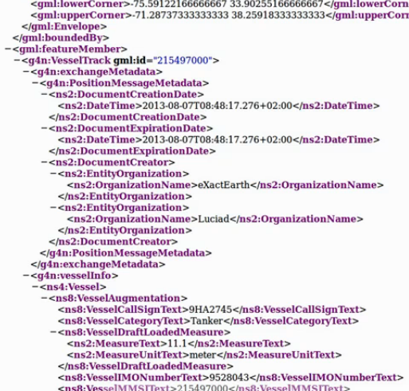
Figure-8- the part of code of API
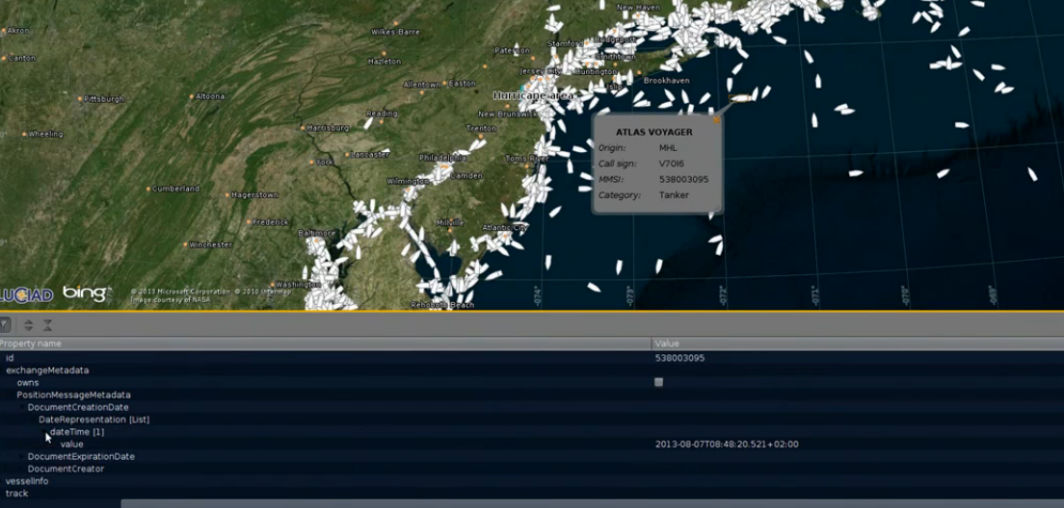
Figure-9- the arrangement of coast guard in a special time

For the solution-design of land route, we think each city as a point in the graphic (figure-1) and we assume that, in the beginning, every city could be a safe destination and every road could be safe for us to transport the drug. (As figure-2 shows below)
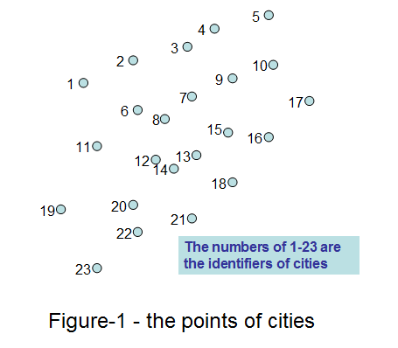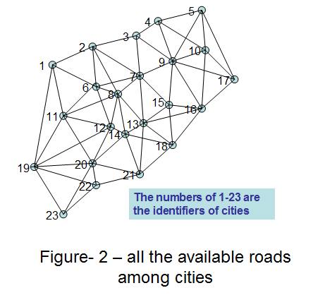
However, in fact, you know, we don’t have too many manpower, and we cannot arrange them to every single city (e.g. there are 100 points on the graphic, but we do have only 50 men.). Moreover, for a complicated graphic, the complexity of algorithm to figure out a best route is really high (, n is the total number of point). As a smart and calculative drug manager, we never run a complicated model which will take us a really long time. In the meantime, nowadays, as more and more seizures arise in these years, there is more and more useful information we can get on the Internet. Therefore, we can mark out (figure-3) and cut off (figure-4) some unnecessary points in which seizure happened.

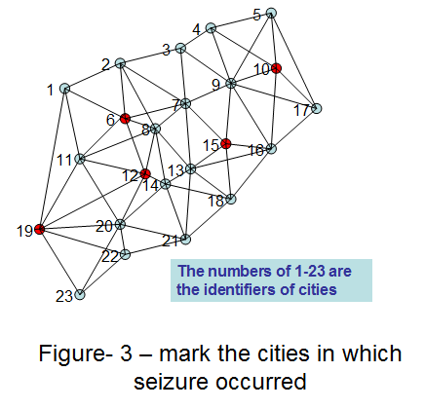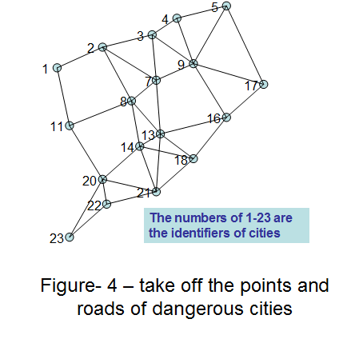

If after cutting off the seized-point there is no route connecting the beginning and ending, we will add the point back to figure one by one, based on the ascending order of the times of seizure.

Of course, in another side, after our simplifying the micromap, the map could still be complicated, so, we need to simplify the map further. As everyone knows, the action of law enforcement is unpredicted and very hard to get. Therefore, although we may get some information in a lot of ways, the action of law enforcement is dynamic. In other ways, the places of checkpoint are set changefully. To guarantee safety of transporting road, we set sentries in the points, which are closest to our place, to get the newest real-time data. If we find the law enforcement set several unexpected checkpoints in the way of our pathways, we can cut off these edges from our map, and search a new route to our destination. (Shown as figure-5 and figure-6)
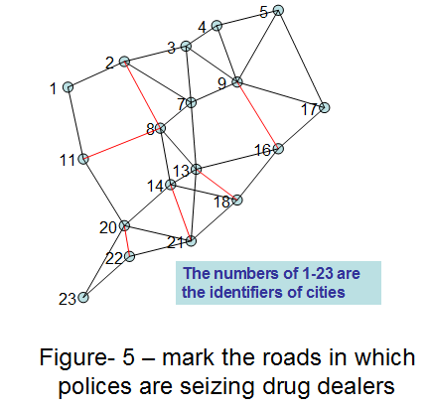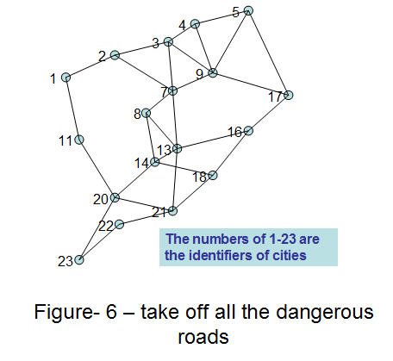

By the way, in order to keep manpower enough, we use a structure of “queue”, which means for the farthest points we’ve already passed, we could repeal the sentries set in these points, and rearrange them to other points. (as figure-10 shows; Notice: only repeal the sentries in some points, rather than all the points we passed ‘cause we may return back to the point we passed before )
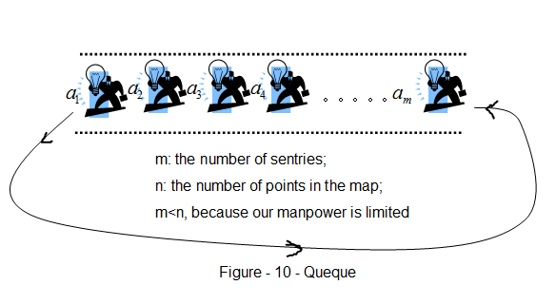

Finally, getting the real-time map is not enough. Under the condition of safety, we also need to try to get the destination, taking the shortest route and costing the cheapest transportation expense. As we all know, there are two ways of searching for a route – Depth First Search (DFS) and Breadth First Search (BFS). However, in this case, the movement of law enforcement is unpredicted, so, obviously, our design must also be very flexible. The algorithm of BFS can only search the shortest route, but it cannot change the route in any possible time. Therefore, we take the algorithm of DFS when we design the route based on the all-the-time-revised map.

